* Log in [Service-Now](https://activenetwork.service-now.com/navpage.do)
* Click Report an Incident – Repair/Question
* Input necessary information and attach script file (without script of rollback)

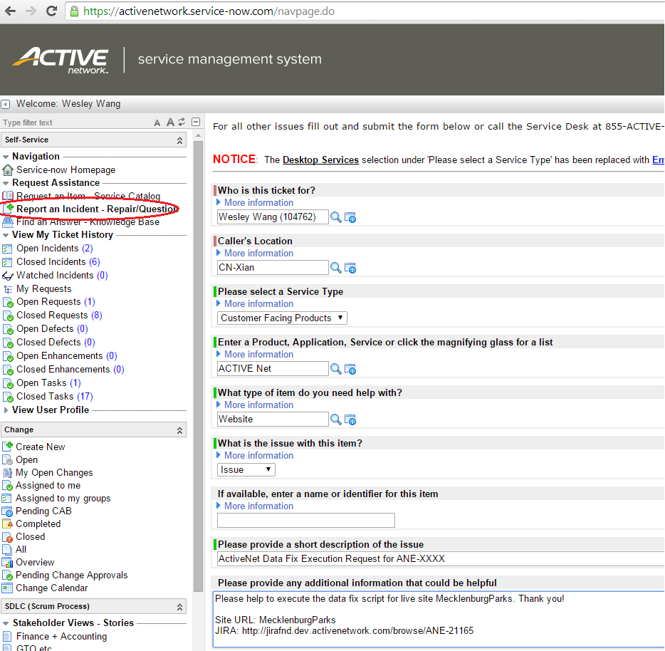

* Add relevant colleagues into Caller Watch List, for example Dev Manager, Project Manager, Reporter and so on.
* Notice this ticket number in comments of JIRA.
* If attached script is fail, we need create new ticket to run script of rollback